Role of Mandir (Hindu Temple) in Hindu Dharma / Hinduism.
Hinduism, also known as Sanatana Dharma, or "Eternal Way," is our planet's original and oldest living religion, with over one billion adherents.
All Hindus worship one Supreme Reality, though they call it by many names. In Hinduism, here is no eternal hell, no damnation, and no intrinsic evil, and no satanic force that opposes the will of God. Hindus believe that the cosmos was created out of God and is permeated by Him--a Supreme Being who both is form and pervades form, who creates, sustains and destroys the universe only to recreate it again in unending cycles. Each soul is free to find his or her own way, whether by devotion, austerity, meditation, yoga or selfless service.
Some of Hinduism's important pillars are temple (Mandir) centric culture/worship, Scriptures (like Vedas, Ramayan, Mahabharat etc) and the guru-Shishya tradition Karma Theory, belief that “truth is one but forms are many” etc.

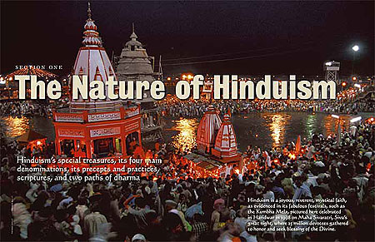
Hindu communities revolve around the local temple, which serves as the hub of culture, worship, festivals and more. For the devout, the ideal is to attend a puja at the community temple daily, or at least once a week, and to participate in the major holy festivals celebrated within its precincts. This allows us to experience the blessings of God and the Gods regularly and to enjoy frequent fellowship with other devotees, which is uplifting and engaging. Although God is everywhere, it is easiest to receive His blessings at the temple.
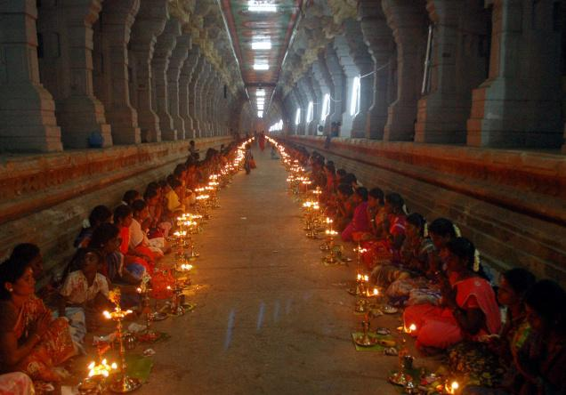
Schools will educate the brain, but who will educate the mind? Hospitals will mend a broken arm, but who will mend a broken heart? Cinemas and arcades will excite the mind, but where will one go for peace of mind? The Mandir is a center for learning about man, nature and God. It is where ethics and values are reinforced. It is where people celebrate festivals and seek shelter in sad times. It is where talents in various arts--music, literature and sculpture--are offered in the service of God.
But there is a broader, seldom discussed, understanding of the temple in Sanatana Dharma which embraces two other sacred places of communion as equally important. One is the home shrine, or Griha Mandira, and the other is the soul temple or Atma Mandira.

The Home Shrine, Griha Mandira
The ideal Hindu home centers around the home shrine, a special room set aside and maintained to create a temple-like atmosphere which holds us close to our spiritual goals and practices. In this holy space we conduct puja, read scriptures, perform sadhana, sing bhajans and do japa. Here we can always feel the presence of God and the Gods, whom we honor especially in the morning and evening and before meals, which we offer to them before we partake.
Performing your own individual puja in the home shrine with sincerity and regularity unfolds a relationship with the Divine that is likened to that of a child to a parent.

The Soul Temple, Atma Mandira

The third place of worship is the temple within the body, which is called the “Atma Mandira.”
This is a internal form of worship/meditation centered in our immortal, spiritual body of light. During this worship we strive to merge with God within. Consistent practice of meditation has the power to increase our concentration, observation, understanding, compassion, appreciation, cooperation, mental acuity, emotional stability, willpower and our ability to see God in all things and all people.
Awakening Wisdom
God abides in all three of these temples. In the community temple God is worshiped in elaborate, formal ways, mystical ways that bring Shakti, or power, into the inner chamber to bless the world. In the home shrine, God is worshiped in simple, loving ways which bring God’s presence into the home to guide the family through karma's sometimes difficult passages and bless their pursuits. In the chamber of the heart, God is worshiped as the Life of life and as the Self of ourselves to awaken peace of mind, insight, inspiration and enlightenment. The three temples stand as a important pillars of Hindu life.

Sources : Hinduism today magazine, Hinduism teachers guide, VHPA UK publication

