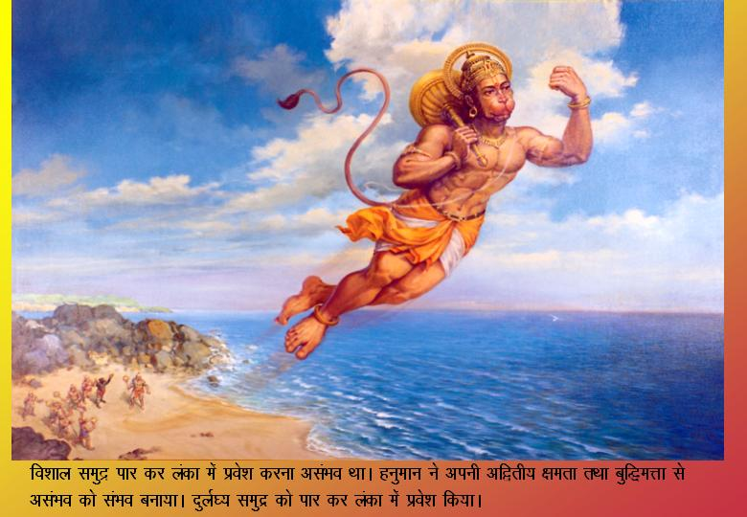
Hanumanjiji means work done!!!!!

Udyama saahasam dhairyam
Budhih shaki parakramaha
Shadete yetra vartante
Tatra devaaha saahaayKruth
-From A Subhashith

God will help person(s) only if they peruse following six things:
Entrepreneurship /Effort, Adventure, Bravery, Intelligence, Strength, Courage.

This story of Hanumanjiji shows how Hanumanji had these qualities in his life and works.

Hanumanji displays effort, courage, intelligence, and the power to overcome obstacles when he meets Surasa (one of Deva’s messengers disguised as a raakshasa) while flying over the Indian Ocean. Surasa says, “Enter my mouth. I have been without food for a long time and I was eagerly waiting for you .” Surasa opened her mouth as wide as a cave. “I am here fulfilling Rama’s wishes. Do not stop me.” said Hanumanji. “Impossible! You must enter my mouth,” says Surasa. As Surasa opens her mouth wider and wider, Hanumanji made his body bigger and bigger. When Surasa’s mouth was enormously wide, Hanumanji contracted his body into a tiny speck, darting through her mouth and body, then, swiftly flying out. Hanumanji said, “you have your wish Surasa. I have entered your mouth. What more do you need?”

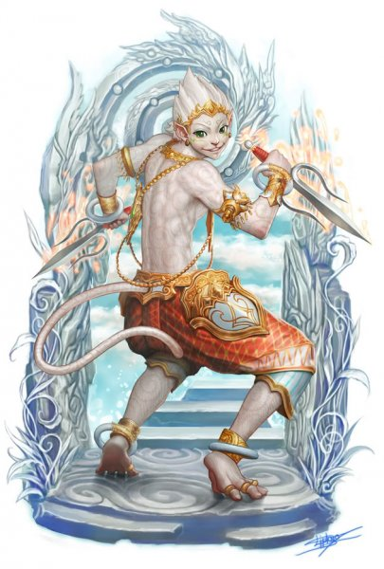
Hanumanji demonstrates his intelligence by fulfilling the Surasa’s wish. He enters her mouth and comes out safely. He shows courage by not hesitating to face Surasa’s might. The Naaga goddess blessed him saying, “Your effort will be crowned with success. I did this at the wish of the gods who wanted to test you.”

Hanumanji demonstrates his strength by ripping through Simhika’s body while flying across the Indian Ocean to Sri Lanka. As he was flying through the sky, he found his speed slowing as if something was preventing him from flying. He looked around and finally discovered the cause. It was a huge she-demon in the sea holding his shadow below, dragging him down. The demon said,” Come, come! I have been waiting for you for a long time. No longer can I bear my hunger.” Then she opened her mouth like a cave. At once Hanumanji entered her mouth and ripped a way through her insides and emerged. The demon died and sank down into the water.
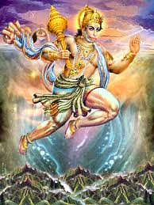
Hanumanji displays the power to overcome obstacles both friendly and unfriendly. For instance, when the mighty mountain Mynaaka was shooting up suddenly from the sea, and stood in his way. He said, “Both the Ocean and I will be pleased of you accept my hospitality and rest here for a while.” Hanumanji thanked the mountain and continued on his flight. He resisted Mynaaka’s tempting offer which would have delayed his work.

Hanumanji shows adventurous spirit and effort by taking on the difficult task of going to Sri Lanka, see Sita and talk to her, and returning safely to tell his team about Sita’s whereabouts.

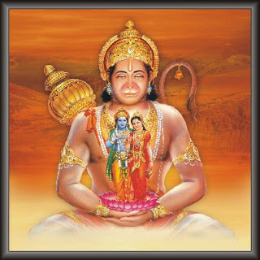
Hanumanji also shows intelligence when he is in the Ashoka Vanam. While he is waiting to talk to Sita, he wanted to make sure that she didn’t suspect him to be Ravana’s messenger. Hanumanji considered about what form he should appear in front of Sita. In what language should he speak to her? He wondered that if he suddenly appeared, Sita would suspect foul play. He decided that when he approached her, he would recite in a sweet low tone, for Sita’s ears only, the story and virtues of Rama. Her heart then would be filled with joy and trust. Hanumanji then sang the story of Rama. Sita’s heart became soft and affectionate. Hanumanji tells her more about Rama and assures Sita to have hope and that Rama will come soon.

Hanumanji demonstrates all six traits off the verse. Luck came to him when he found Sita in Ashoka Vanam after failing to find her in Ravana’s palace. He fulfilled his promise to find Sita. He also saved all the lives of the Vaanaras. Hanumanji demonstrated these qualities/traits.

- This article is based off of a contest entry in Balagokulam.

