Elementary School:

- Exercise E1: Color Mataji’s picture and color it.
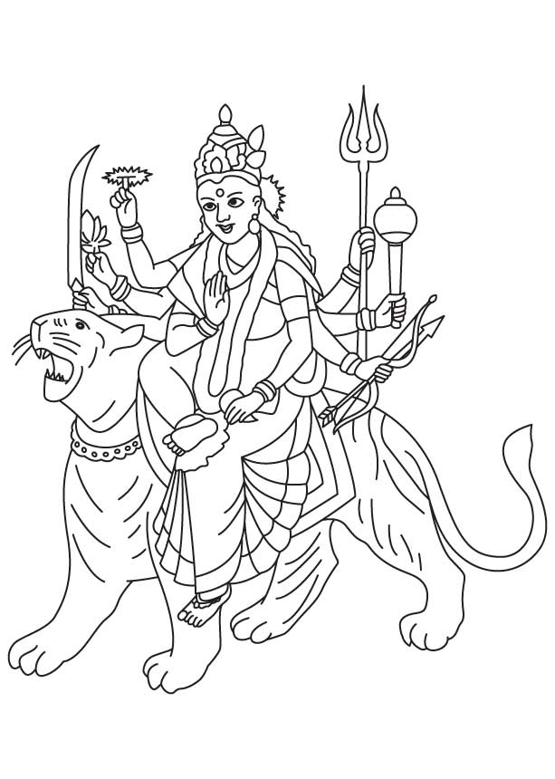

- Exercise E1 – Part B
Find the hidden message on unification of India

S G H A K T T I P C P E F E T
A S N S P R H E I U N K O L E
D T H I R O E R D L U G R H O
U T I N Y T D E O T I A C W H
I C H I A F L S C U U L E T U
R A L S L K I Y U R G N I F Y
I N G F N O R N C A E H O F B
I N D I A H A R U L A T O + +
+ + R H C I H W + L + + + U +
+ P + + + + + + + Y + + + + T
S + + + + + + + + + + + + + +
+ + + + + + + + + + + + + + +
B H A R A T + + + + + + + + +
+ + + + + + + + + + + + + + +
+ + + + + I T K A H S + + + +

(Over,Down,Direction)
BHARAT
CULTURALLY
FORCE
INDIA
PEETAS
SHAKTI
SPRINKLED
THROUGHOUT
UNIFYING
WHICH

Exercise E2: Learn on how handle tricky situation:
Krishnadevaraya was a great king wanted to build a superior army of horses. King used to get excited when he see well bread horses and wanted to buy.

One day a horse trader, a foreigner from an Arabian Country, came to his court and announced, " I have some fine horses for sale . They are the best Arabian steeds you can get in the whole world. I have brought one horse to show you. If you like him I can send in for the others ". The Emperor was very excited by the offer, as the only breed he didn't have in his stables were the Arabian steeds. He saw the majestic horse standing outside his palace and immediately offered to buy the whole lot of them. The man took an advance of 5000 gold coins and promised to return with the whole set of horses in 2 days and went away.
Two weeks passed and the King saw no sign of the trader. He was growing a little impatient and went out into his garden for a stroll to take his mind off the trader. He saw Raman sitting in the corner of his gardens, and scribbling something on a sheet of paper without looking at the king.. The King was very curious and demanded " I command that you show me what you are writing immediately." "Well sir, you may not like it, but I'm making a list of greatest fools in the empire", said Raman.

The king was amused by Tenali’s answer and could not wait to see the list. When king saw the paper, his face became red with anger.., King shouted at Raman" How dare you write my name on top of the list Raman? It is punishable with harsh penalty? I demand an explanation on why do you think I am a fool indeed!"
Raman says "Any man who would give 5000 gold coins to a complete stranger and expect him to return, is a fool!" replied Raman.
King took a deep sigh and said " You think the man won't return. What if he does? You are wrong then"
"In that case", YOU in the Raman’s position will say with a brilliant smile, ______________

Raman said with with a twinkle in his eye " ____________________________________" The King understood the wise words behind Raman's wit and never again made any major decisions without consulting his witty and trusted minister.

- Exercise E4 : Sharpen your brain logical puzzles

- The thing in your home has seven letter name. If you take out one letter from it does not change. You take out two letters from it does not change. If you take all letters from it also still it remains the same. Whati is it?

- Mandir shipment is received at customs. It had three boxes containing Gods pictures. The shipping company made mistake in labelling all three boxes. One box is labeled "SRI KRISHNA" another is labeled "SRI RAMA". The last one is labeled "SRI KRISHNA AND SRI RAMA". Shipping company labeled incorrectly did not know who is ShriRam and who is SriKrishan. Customs office said that they give only one chance to look at one of three boxes to correct all three boxe’s label.
Of course we know you that you are smart children and can identify Ramji and Krishanji and correct all labels by looking at one box. How do you do it?
- What is the right choice to complete empty space?
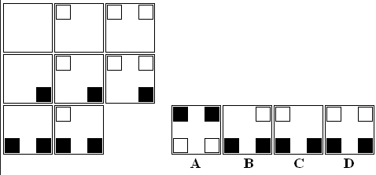

Exercise E5: Help Ambaji to Kill Mahishasur Rakshas
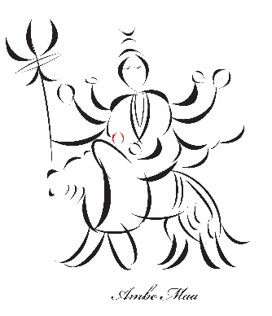

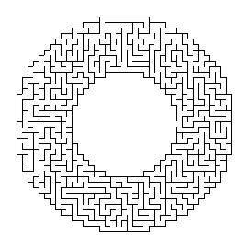
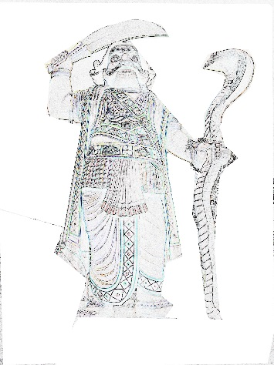

Middle School:
Exercise M1 – Weapons of Durga – cryptogram puzzle, Shakti Peeta hidden message
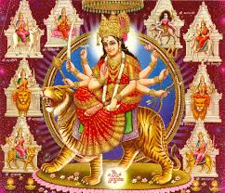
Durga, the Mother Goddess of the Hindus, worshipped in the form of Devi (benevolent form) and Shakti (the goddess of power). NavaDurga means nine Goddess, manifestation of Durga in nine different forms. All forms are worshipped during the Navratri (Nine Divine Nights) celebration in autumn each year.
Nava – that also means 'new' – denotes 'nine' the number to which sages attach special significance. Hence, we have Nava-ratri (9 nights), Nava-graha (9 planets), and Nava-Durga (9 different forms).
The word ‘Durga’, itself means undefeatable, and this is why too most of the Devi’s temples are built atop hills.
Durga (the goddess of power) is seated on a tiger in a fearless pose (Abhay Mudra) signifying assurance of freedom from fear. Tiger represents power, will and determination. She can be seen holding her weapons (a long Trishula/trident with upper hand of right side and lower hand of left side, a Chakra, a conch shell, a Mace, a Talwar/longsword, a lotus and a bow) with her hands. Complete the puzzle and write what you found out regarding Durga’s weapons.

A | B | C | D | E | F | G | H | I | J | K | L | M | N | O | P | Q | R | S | T | U | V | W | X | Y | Z
8 |  |  |  | 7 |  |  |  |  |  |  |  |  | 12 | 2 |  |  | 22 | 9 |  |  | 1

__ | __ | R | __ | A |  | __ | S | E | S |  | __ | E | R |  | __ | E | A | __ | O | N | S |  | __ | O
15 | 20 | 22 | 13 | 8 |  | 20 | 9 | 7 | 9 |  | 14 | 7 | 22 |  | 6 | 7 | 8 | 24 | 2 | 12 | 9 |  | 25 | 2

__ | E | S | __ | R | O | __ |  | E | V | __ | __ | S |  | A | N | __
15 | 7 | 9 | 25 | 22 | 2 | 11 |  | 7 | 1 | 5 | 10 | 9 |  | 8 | 12 | 15

E | N | __ | O | __ | R | A | __ | E |  | R | __ | __ | __ | __ | E | O | __ | S | N | E | S | S
7 | 12 | 18 | 2 | 20 | 22 | 8 | 13 | 7 |  | 22 | 5 | 13 | 14 | 25 | 7 | 2 | 20 | 9 | 12 | 7 | 9 | 9

Exercise M2: Try some matchstick puzzle fun

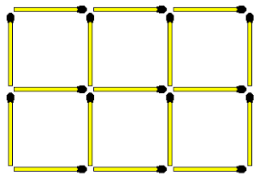
- remove 3 sticks leave 4 equal squares; remove 4 sticks leave 4 equal squares;

- Move only on stick to correct the equation. Hint : numbers need not be in Roman numeral

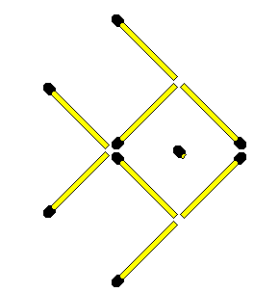

- Change the direction of the fish
swimming from East to South direction.

Exercise M4: Puzzles AdiShakti: crisscross

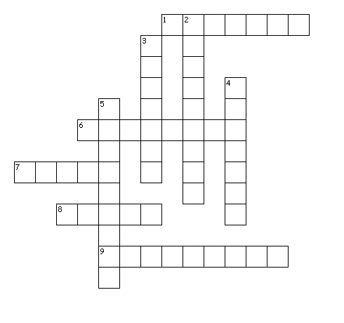

Across
1. : The goddess of wealth and fertility
6. : The Goddess of destruction of evil
7. : The Goddess of strength and valor
8. : The goddess of benevolence.
9. : Personified in the form of Bramha, Vishnu, Shiva
Down
2. : The Goddess supreme cosmic energy which exists from the beginning of universe.
3. : The Goddess of destruction of evil
4. : Three main female forms of God
5. : The goddess of learning

Exercise M5 – Math and logic puzzle, sharpen your brain

- What is the value of 1/2 of 2/3 of 3/4 of 4/5 of 5/6 of 6/7 of 7/8 of 8/9 of 9/10 of 1,000?
- If
1 = 5
2 = 25
3 = 325
4 = 4,325.
Then 5 = ?
- What is as big as you are and yet does not weigh anything?

- You can hold it without using your hands or arms. What is it?

A ship anchored in a port has a ladder which hangs over the side. The length of the ladder is 200cm, the distance between each rung in 20cm and the bottom rung touches the water. The tide rises at a rate of 10cm an hour. When will the water reach the fifth rung?

High School:
Exercise H1: Weapons of Durga – cryptogram puzzle, find the hidden message on Shakti Peetas
Durga, the Mother Goddess of the Hindus, worshipped in the form of Devi (benevolent form) and Shakti (the goddess of power). NavaDurga means nine Goddess, manifestation of Durga in nine different forms. All forms are worshipped during the Navratri (Nine Divine Nights) celebration in autumn each year.
Nava – that also means 'new' – denotes 'nine' the number to which sages attach special significance. Hence, we have Nava-ratri (9 nights), Nava-graha (9 planets), and Nava-Durga (9 different forms).
The word ‘Durga’, itself means undefeatable, and this is why too most of the Devi’s temples are built atop hills.
Durga (the goddess of power) is seated on a tiger in a fearless pose (Abhay Mudra) signifying assurance of freedom from fear. Tiger represents power, will and determination. She can be seen holding her weapons (a long Trishula/trident with upper hand of right side and lower hand of left side, a Chakra, a conch shell, a Mace, a Talwar/longsword, a lotus and a bow) with her hands. Complete the puzzle and write what you found out regarding Durga’s weapons.
A | B | C | D | E | F | G | H | I | J | K | L | M | N | O | P | Q | R | S | T | U | V | W | X | Y | Z
8 |  |  |  | 7 |  |  |  |  |  |  |  |  | 12 | 2 |  |  | 22 | 9 |  |  | 1

__ | __ | R | __ | A |  | __ | S | E | S |  | __ | E | R |  | __ | E | A | __ | O | N | S |  | __ | O
15 | 20 | 22 | 13 | 8 |  | 20 | 9 | 7 | 9 |  | 14 | 7 | 22 |  | 6 | 7 | 8 | 24 | 2 | 12 | 9 |  | 25 | 2

__ | E | S | __ | R | O | __ |  | E | V | __ | __ | S |  | A | N | __
15 | 7 | 9 | 25 | 22 | 2 | 11 |  | 7 | 1 | 5 | 10 | 9 |  | 8 | 12 | 15

E | N | __ | O | __ | R | A | __ | E |  | R | __ | __ | __ | __ | E | O | __ | S | N | E | S | S
7 | 12 | 18 | 2 | 20 | 22 | 8 | 13 | 7 |  | 22 | 5 | 13 | 14 | 25 | 7 | 2 | 20 | 9 | 12 | 7 | 9 | 9

Exercise H2: Puzzles AdiShakti: crisscross

Across
1. : The goddess of wealth and fertility
6. : The Goddess of destruction of evil
7. : The Goddess of strength and valor
8. : The goddess of benevolence.
9. : Personified in the form of Bramha, Vishnu, Shiva

Down
2. : The Goddess supreme cosmic energy which exists from the beginning of universe.
3. : The Goddess of destruction of evil
4. : Three main female forms of God
5. : The goddess of learning

Complete the face using symmetry and your artistic skills

Exercise H4: Math and Statistical riddles
- Complete Statistics riddles :

- What is the value of 1/2 of 2/3 of 3/4 of 4/5 of 5/6 of 6/7 of 7/8 of 8/9 of 9/10 of 1,000?
- If
1 = 5
2 = 25
3 = 325
4 = 4,325.
Then 5 = ?

- Which of these two business you choose to run ?
-The one which gives 20% annual return on investment
-The one which gives 1 % return on sales
Hint :
- You invest $100 and at the end of the year you get $120
- Suppose you have $100, and buy 98 papers for 98 cents each and sell for 100 cents. Out that lets say your selling cost it $1 and your profit is $1 which is 1% return on sales. Use the $100 next day to repeat the same business and you do it for 365 days. Your return on sales is $365 on your initial investment of $98. That means your annual return on sales is 365/95 * 100 = 372 %

Adults:

- Exercise A1: Adi Shakti Criss-Cross

- Across
- 1. : The goddess of wealth and fertility
- 6. : The Goddess of destruction of evil
- 7. : The Goddess of strength and valor
- 8. : The goddess of benevolence.
- 9. : Personified in the form of Bramha, Vishnu, Shiva
- Down
- 2. : The Goddess supreme cosmic energy which exists from the beginning of universe.
- 3. : The Goddess of destruction of evil
- 4. : Three main female forms of God
- 5. : The goddess of learning

Exercise A2: Try some matchstick puzzle fun

- remove 3 sticks leave 4 equal squares; remove 4 sticks leave 4 equal squares;

- Move only on stick to correct the equation. Hint : numbers need not be in Roman numeral

- Change the direction of the fish
swimming from East to South direction.

Exercise A4: Illusions right or wrong?

Optical Illusions

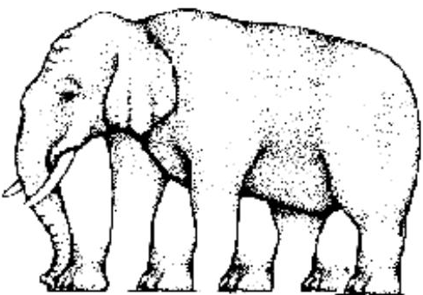

Color and count legs this elephant have? Is the left center circle is bigger than the right center circle?

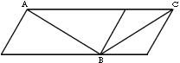

Which line is bigger AB or BC?

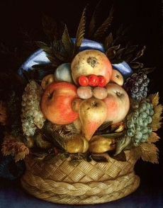

Are these steps zig-zaged?

What do you see fruits? or faces?

