Elementary School:

Exercise E1 : Draw and color Kalash



C:\Shivaram\VHPA\Camps\Camp2013\Exercises\big-hanuman.tif

Exercise E5 : Draw and color Hanumanji

Exercise E4 : Sharpen your brain

1. A man shows a photo at his home to his friend and describes the person in that photo as“ That

mans’ father is my father’s son, an you know that I don’t have any brothers or sisters..” . At whose picture he was looking ?

1. Our teacher asks you to bring exactly 4 gallons of water from a pond.

Teachers gives you only two measuring jars which can hold 3 gallon and 5 gallons.

How do you get exact 4 gallons of water?

Middle School:

Exercise M1 : Char Dham cryptogram puzzle.

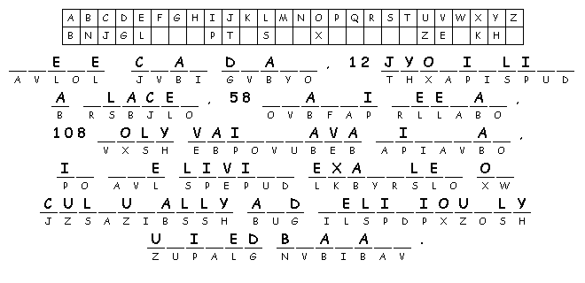

Exercise M2 : Math and logic puzzle, sharpen your brain:

1. Draw Four straight lines and make 10 equal

squares in the picture

1. Use addition (+), subtraction (-), multiplication (*), division (/), grouping ( )symbols

in between to get required number

1 = 4 4 4 4

2 = 4 4 4 4

3 = 4 4 4 4

6 = 4 4 4 4

7 = 4 4 4 4

8 = 4 4 4 4

1. Pingala Junior can you prove this?

Let CE = BC = a, CD = AC = b, DE = AB = c. F is an intersection point between A and B.

Prove that b² + a² = c²

Hint : Area(ΔABD) = Area(ΔABE) + Area(ΔACD) + Area(ΔBCE)

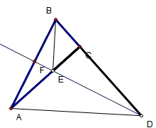

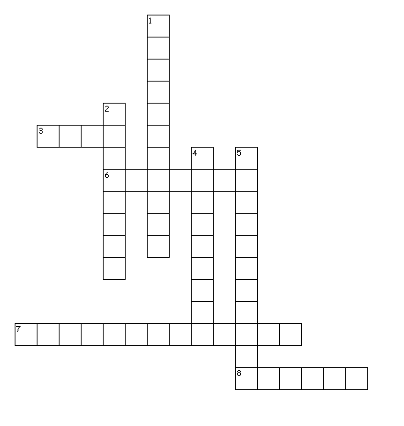Exercise M4 : Puzzles on Char Dham Yatra : criss-cross

Across

3. - This is one of Char Dham which is in East side

6. - This is one of Char Dham which is in West side

7. – This monk established monasteries in Char Dhams

8. – Religious center of Hindus

Down

1. - Hindus Holi places tour is called..

2. – the bonding force of people in Bharat

4. – This is one of Char Dham which is in North side

5. - This is one of Char Dham which is in South side

Exercise M5 : Mandir accounting

Shaily, Puja, Atish, Hardhik all agreed to provide transportation from nearest school parking lot to Mandir on Janmashtami day. Mandir told them that it will provide their gas cost at $3.50 per gallon they use. The distance between school parking lot to Mandir is 5 miles.

Shaily said she made 12 trips between school parking lot and Mandir.

Atish said he made 4 trips less than Shaily.

Hardik said he made one trip more than Atish,

Puja said she made half number of trips as compared to Shaily.

They said that their car/van give approximately following mileage. Shaily’s car 20 mpg , Puja’s van 15 mpg , Atish’s car 30 mpg, Hardhik’s car 20 mpg. How much money does temple need to give them for their gas expense. (Well… they can donate it as donation later)

Adults :

Exercise A1:

1. Char dham cryptogram and more:



1. Name some of of the Holy temples which are badlyt affected by the recent floods in Uttranchal?
2. What is the current day name of the ancient holy city Avantika ?
3. Which God symbolize as ‘Yagnya’ / Yajnya in Vedic Hinduism ?

Exercise A2 :

1. Kumb Mela find words

|  |  |  |  |  |  |  |  |  |  |  |  |
| --- | --- | --- | --- | --- | --- | --- | --- | --- | --- | --- | --- |
| A | U | K | D | C | D | M | M | U | I | P | A |
| Y | L | P | S | W | A | N | A | P | T | R | G |
| V | U | E | Q | H | A | N | X | W | A | A | N |
| C | T | S | M | S | I | D | U | W | W | Y | A |
| I | G | R | H | H | V | P | D | M | S | A | G |
| O | O | I | Z | L | B | I | R | J | A | G | L |
| Q | K | B | E | H | R | M | S | A | R | Y | K |
| R | N | D | V | A | P | L | U | M | A | Q | V |
| A | E | S | H | P | D | U | G | K | S | Z | B |
| G | O | D | A | W | A | R | I | U | Z | T | F |
| K | N | I | A | J | J | U | J | G | Y | R | G |
| U | Z | Y | R | C | Q | M | X | D | Q | I | V |

|  |
| --- |
|  |
| GANGA | GODAWARI | HARIDWAR |
| KSHIPRA | KUMBHMELA | NASHIK |
| PRAYAG | SARASWATI | UJJAIN |

Exercise A4 : Quizz on Mandirs in Bharat.

1. Name any two classes of the 33 Vedic gods?

2. Give the exact scriptural citation where the 33 Vedic gods are mentioned.

(text, chapter, section and verse)

3. Recite the Vishusahasranama passage which identifies Vishnu with all aspects of

the yajña.

4. What is the name of the set of texts that deal with Hindu temple traditions?

5. Which city is Maya?

6. Name the three most important temples of Kañcipuram.

7. Name the 3 jyotirlinga temples in Maharashtra.

8. Name the only one of the pañcabhuta tattva lingas outside of Tamilnad (temple)

name, associated tattva and state must be given)

9. Which Hindu temple is considered prasadapavana?

10. What is the current-day name of Ekacakrapura of the Mahabharata times?

11. In which city and state is the god Vishu as a lake?

12. Name the Vishnu-svarupa temples with brahma-ending names.

13. Name any four of the eight svayamvyakta ksetras

14. Recite the 12 Akhilabharata punyaksetra sloka.

Exercise A5 : Illusions Right or wrong ?

1. Is Are these holes are on inner surface or outer surface?

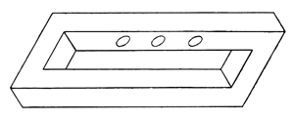

1. Is the smaller circle is perfectly round or not ?

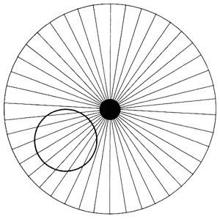

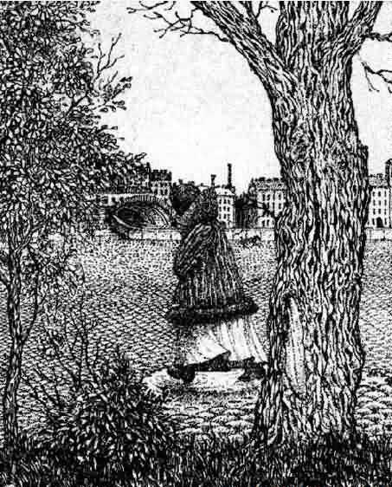

1. Optical illusion, what do you see?

High School:

Exercise H1 :

1. Find the Hidden Message on Gods Will

AND

DAMNATION

ETERNAL

EVIL--NO

FORCE

GOD

HELL

HINDUISM

INTRINSIC

OPPOSES

SATANIC

THAT

THE

THERE

WILL

D C T E H E R E T H E I S N O

E A I T T E R N A L H E L L N

O D M S A E M N A T F I O N I

N H I N N N R D U I O S M A N

D N O I A I S N N T R R I T N

S I C E V T R A A I C L H N O

O S A T A N I T T L E A I P C

H F O R C E T O N A T H P A T

O I P P O S E S N I N O T H O

E A N W I L L O F G S I O D N

V N O D E L A C S E R I C Q L

Y D S D U J I C S R C G O M I

W I L L I I T H E R E O U R V

L L E H Q N S P K H N D X P E

M V T H B J L M O M L L C T O

__ __ __ __ __ __ __ __ __ __ __ __ __ __ __ __ __ __ __ __ , __ __

__ __ __ __ __ __ __ __ __ , __ __ __ __ __ __ __ __ __ __ , __ __ __

__ __ __ __ __ __ __ __ __ __ __ __ __ __ __ - - __ __ __ __ __ __ __ __ __

__ __ __ __ __ __ __ __ __ __ __ __ __ __ __ __ __ __ __ __ __ __ __

__ __ __ __ __

1. Fill in the blanks

Mandir is a center for learning about ---, ------ and ---. It is where ------ and ------ are reinforced. It

is where people celebrate ---------- and seek shelter in --- times. It is where talents in various

---- ------, ---------- and sculpture--are offered in the service of God.

Exercise H4 : Math and Logic puzzles

1. A man starting work on Monday June 1st. He said to his boss that would take 1c on first day, 2 cent on second day and 4c on third day, doubling his salary compared to last day he worked. If he worked for all month except on Sat and Sunday what is the approximate total money he make at the end of that month ?
2. Two square posts, 1 foot to a side, are seated in the ground exactly 2 feet apart from their center. My horse is tied to an anchor on the outside of one post with a rope that is 30 feet long. He likes to walk, but can only go in circles due to the rope and posts. How many times can he go around the posts before he runs out of rope?
3. Aarati bought a pad of paper, a pencil, an eraser and a compass for her class work, for $1.80. Compass costs twice as much as the paper. Eraser costs third as much as the compass. Pencil costs half as much as eraser. What did each cost ?

Exercise H5: - Re-enactment of the above skit with your script and imagination.

Exercise H2: -

# Kumbh Mela Cris-Cross

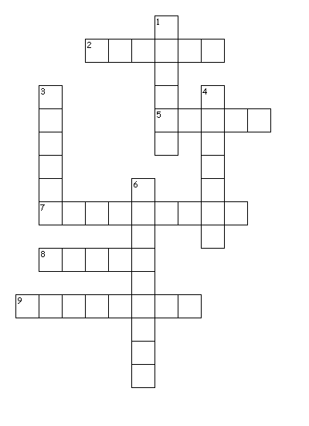

Across

2. - In this place in Madhyapradesh state where Kumbh Mela is held

5. - In this place in Maharastra state where Kumbh Mela is held

7. - This river starts Triambkeshwar Jyotirlinga near Nasik onthe banks of which Kumbh Mela is held

8. - Lord Shiva controled the flow of this river.

9. - Previou Kumbh Mela was held in this Holi city

Down

1. - This river flows near Delhi and in places where Kumbh mela is held.

3. - On this Holy city Kumbh Mela was held this year

4. - On the banks of this river MahaKaaleshwar Jyotirlinga is situated in Ujjain where Kumbh Mela is held

6. - The underground river which makes Triveni Sangam at Prayag